## MaxDS Architecture and Function Workflow

1. Summary  
   MAXDS, the Multiple Application XBRL Delivery System, is a web-based application specifically designed to support financial data application users interpret financial data by developing a “mapping” from the complex data to a simple format in such a way that it works automatically and reliably on new, incoming XBRL from EDGAR, and delivers it to the financial applications without additional manual inspection or cleaning. Developing a mapping typically requires looking at the underlying XBRL data in a variety of different ways. It also requires a kind of rapid cycle of "edit, try it on a lot of filings, debug incorrect results, repeat" that may be familiar to programmers or Excel experts, but not necessarily to accountants.

XBRL data as collected by the SEC is voluminous and its tags are complex and diverse.

1. MaxDS architecture

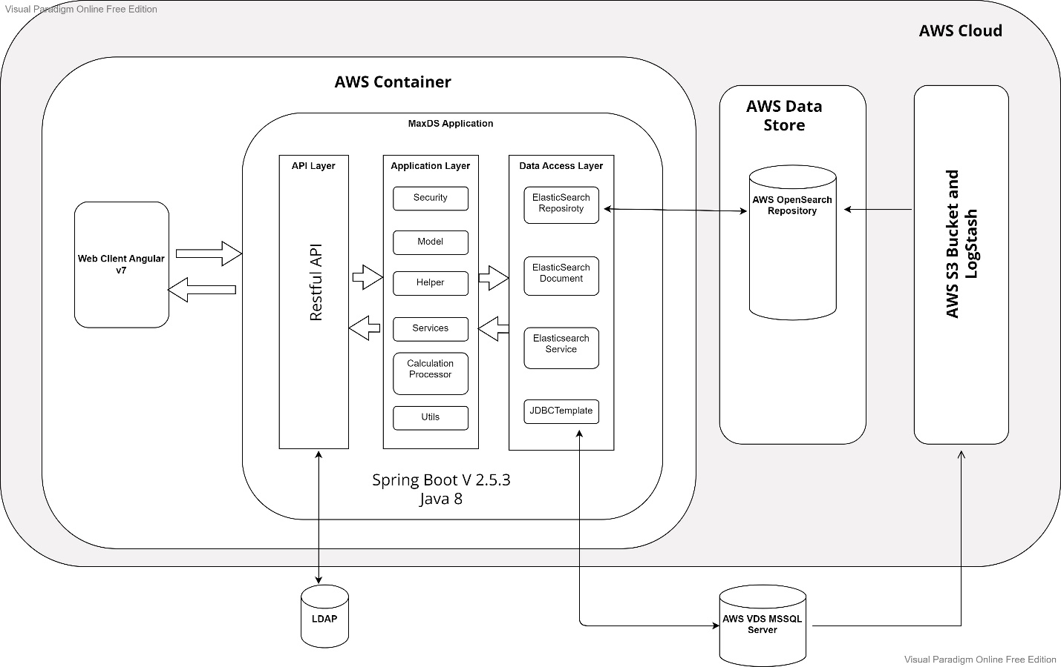

1. MaxDS main components and functions

* Home

Home is the landing page after user successfully login. It provides following functions:

Search Term Rule, Save Term Rule, Edit Term Rule, Create New Term Rule, Process Term Rule on an Entity or Entities, Go to Peer Group for an Entity, Show Term Rule Result for Specific Term.

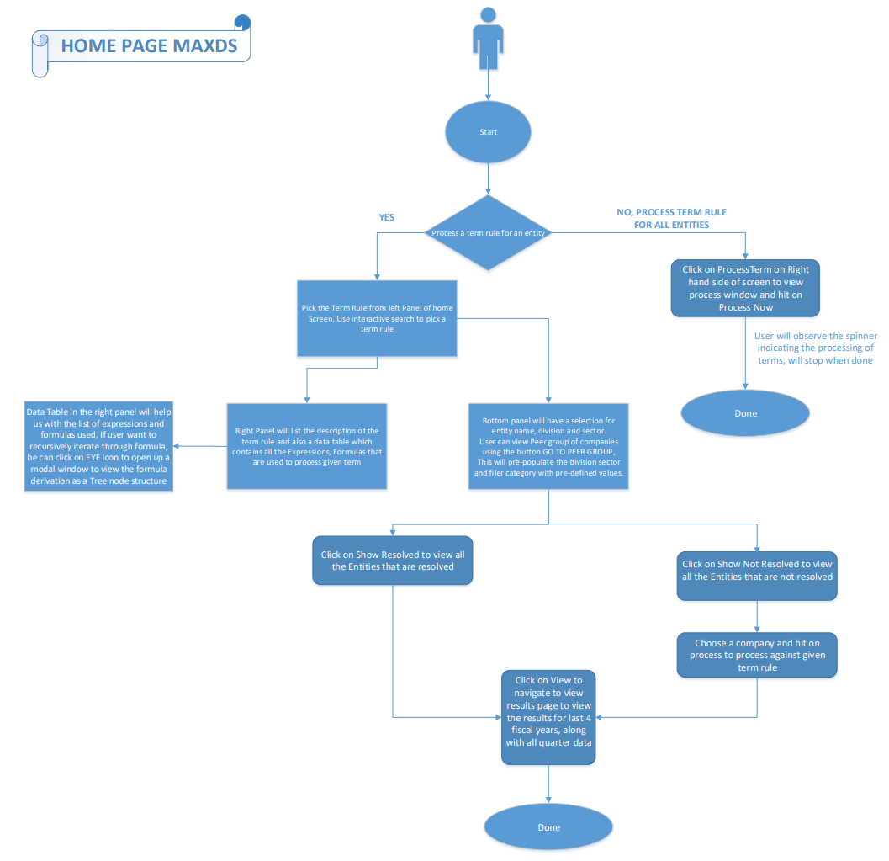

* Export

User can select entity/entities, term/terms, reporting period to process term rule, display term result and export as excel report.

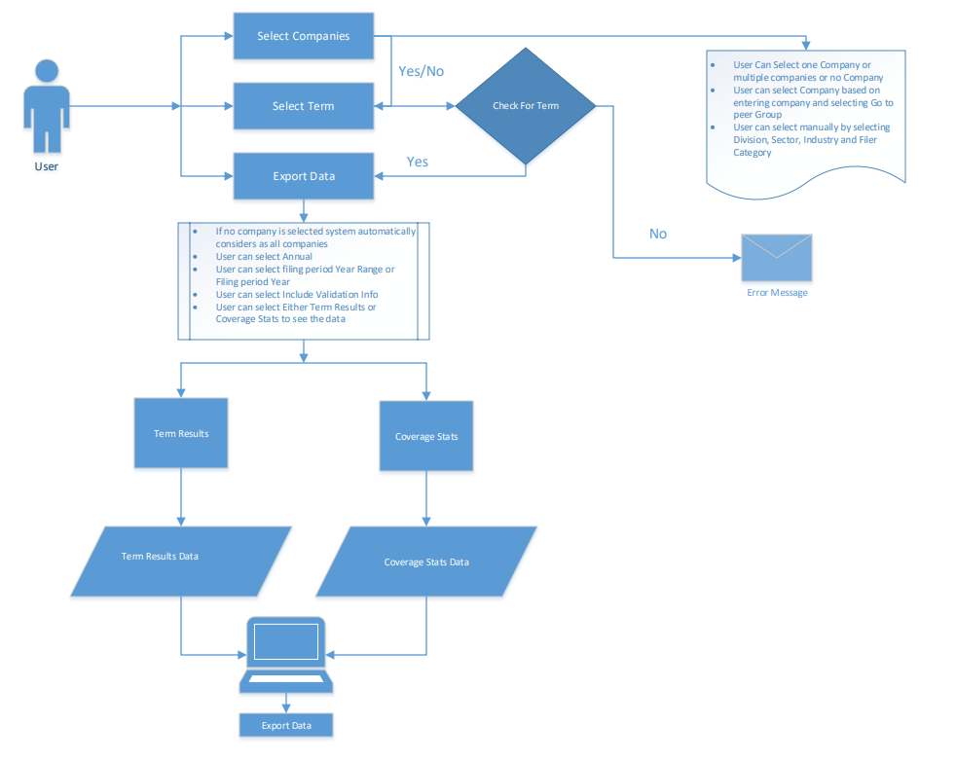

* Accuracy Test

User can select an entity and reporting period to run Accuracy Test. The report shows Form 10-K and financial data comparison chart. The page also provides save and export feature for the report.

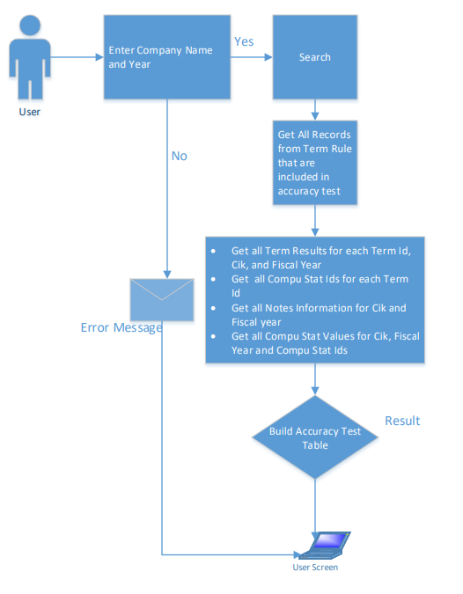

* Process Terms

General users can either process terms based on company or can do it for peer group and Admin user can process all terms for all companies. To process large number of entities, general users can type in, copy/paste, or upload csv file that contain entity CIKs for term processing. Users have privilege of processing selected terms and cancel the ongoing processes.

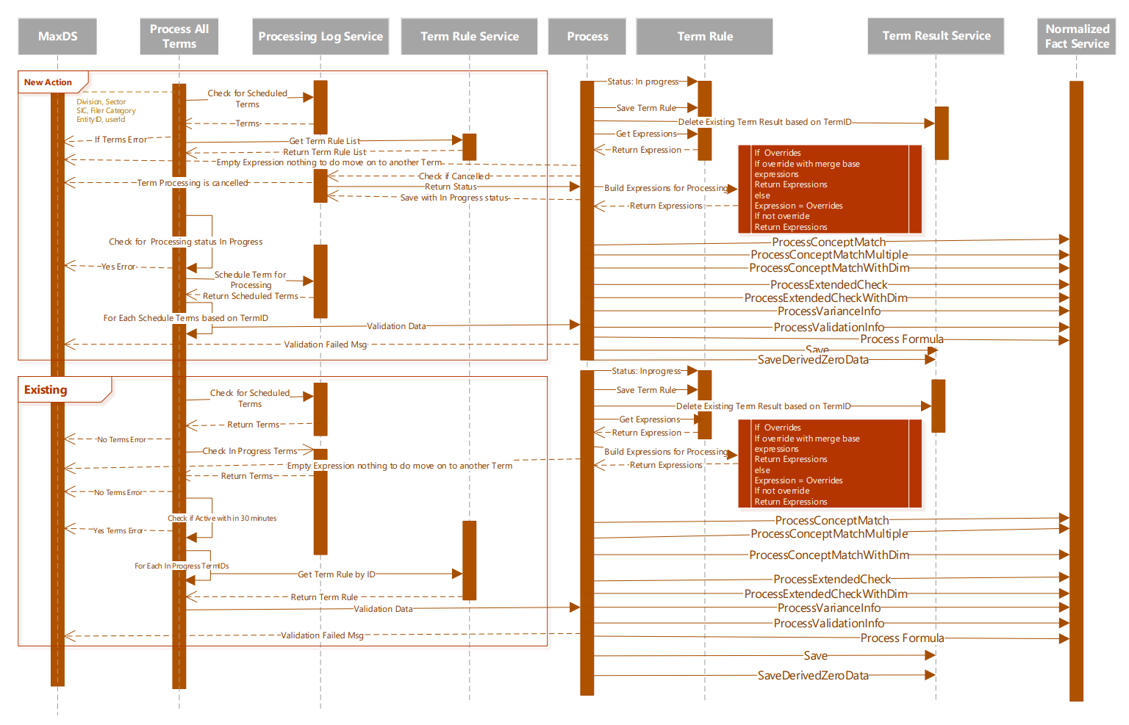

* Manage Term Maps

By doing Show/Hide Group, Delete Group, Create New Group or Create New Row, user can manage the mapping information between MAXDS and other systems on the page. The final result can be exported as CSV file.

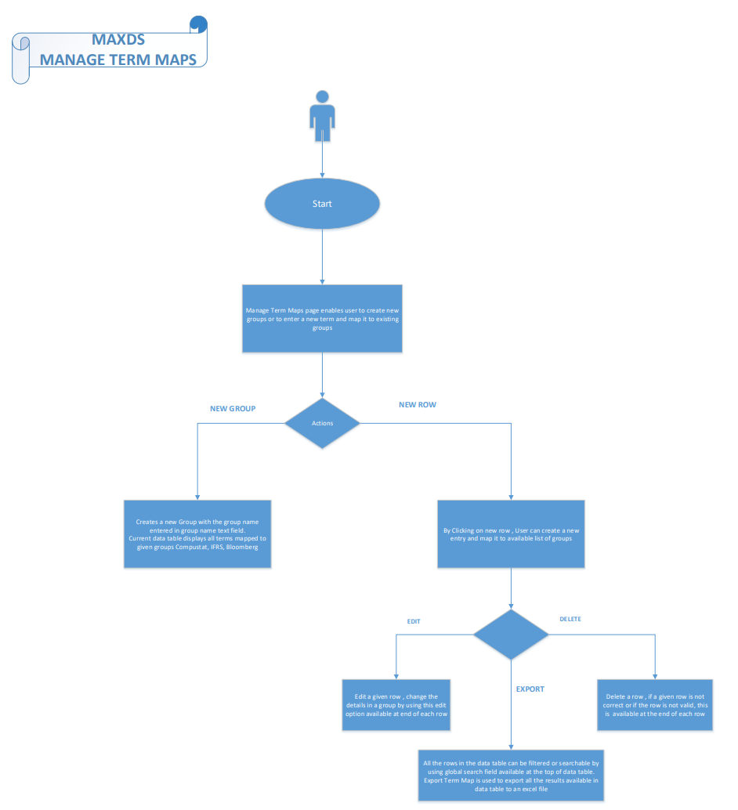

* Status

The Status page shows current running process, completed process or cancelled process in a list format.

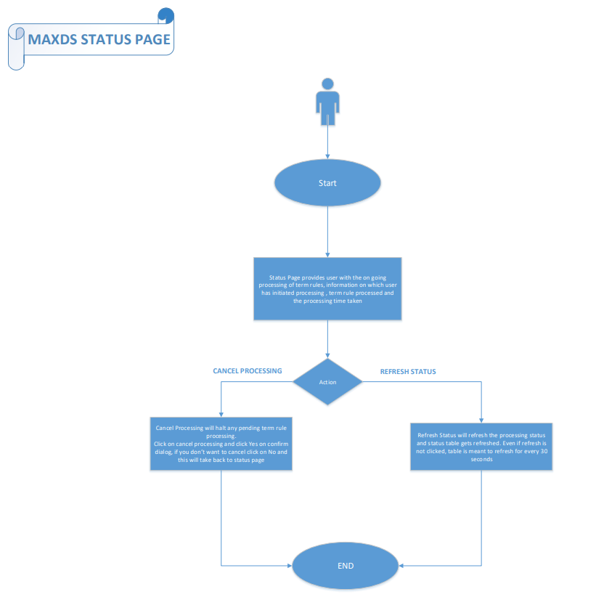

* Submit Feedback

User can submit feedback via email.

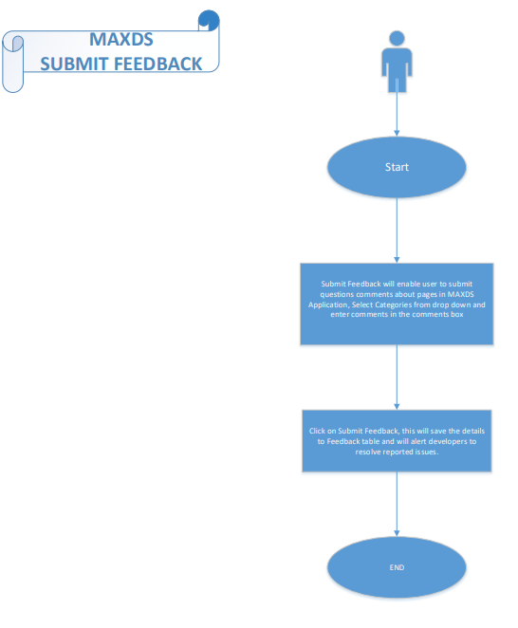

* Profile

User can save favorite combination of term rules and entities for future term rule processing. User can also edit or delete saved term rule and entity, or share with other users.

